23 May 2023, Rudolf

Running Streamlit on MacBook Pro

upload: shell_JOSAA2022_8depths.h5 by Josué

**Optical settings:**

Number of microlenses: 25

Pixels per microlens: 17

Number of voxels per microlens (supersampling): 3

Magnification: 60

NA of objective: 1.2

Wavelength of light: 0.55 µm

camera pixel size: 6.5 µm

refractive index of medium: oil n=1.65

Backend: numpy

**Retardance and orientation images**

Ray-tracing time in seconds: 0.041

Execution time in seconds with backend BackEnds.NUMPY: 37.5

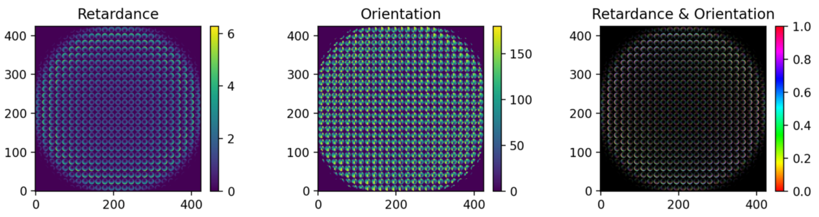

Backend: torch

**Retardance and orientation images**

Ray-tracing time in seconds: 3.0

Using computing device: cpu

Execution time in seconds with backend BackEnds.PYTORCH: 11.0

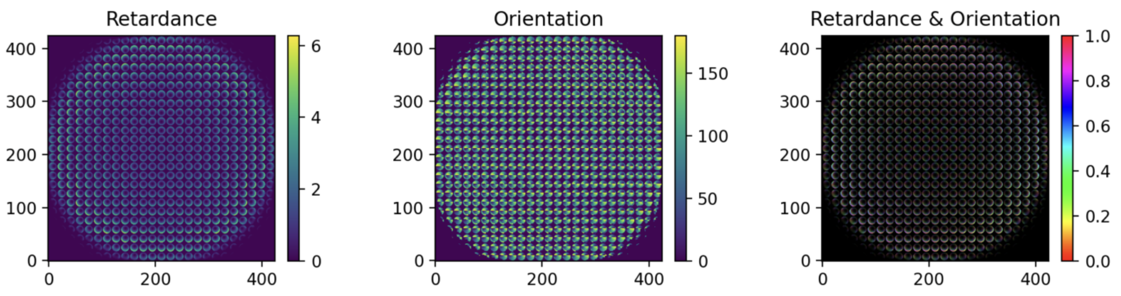

Reconstruction

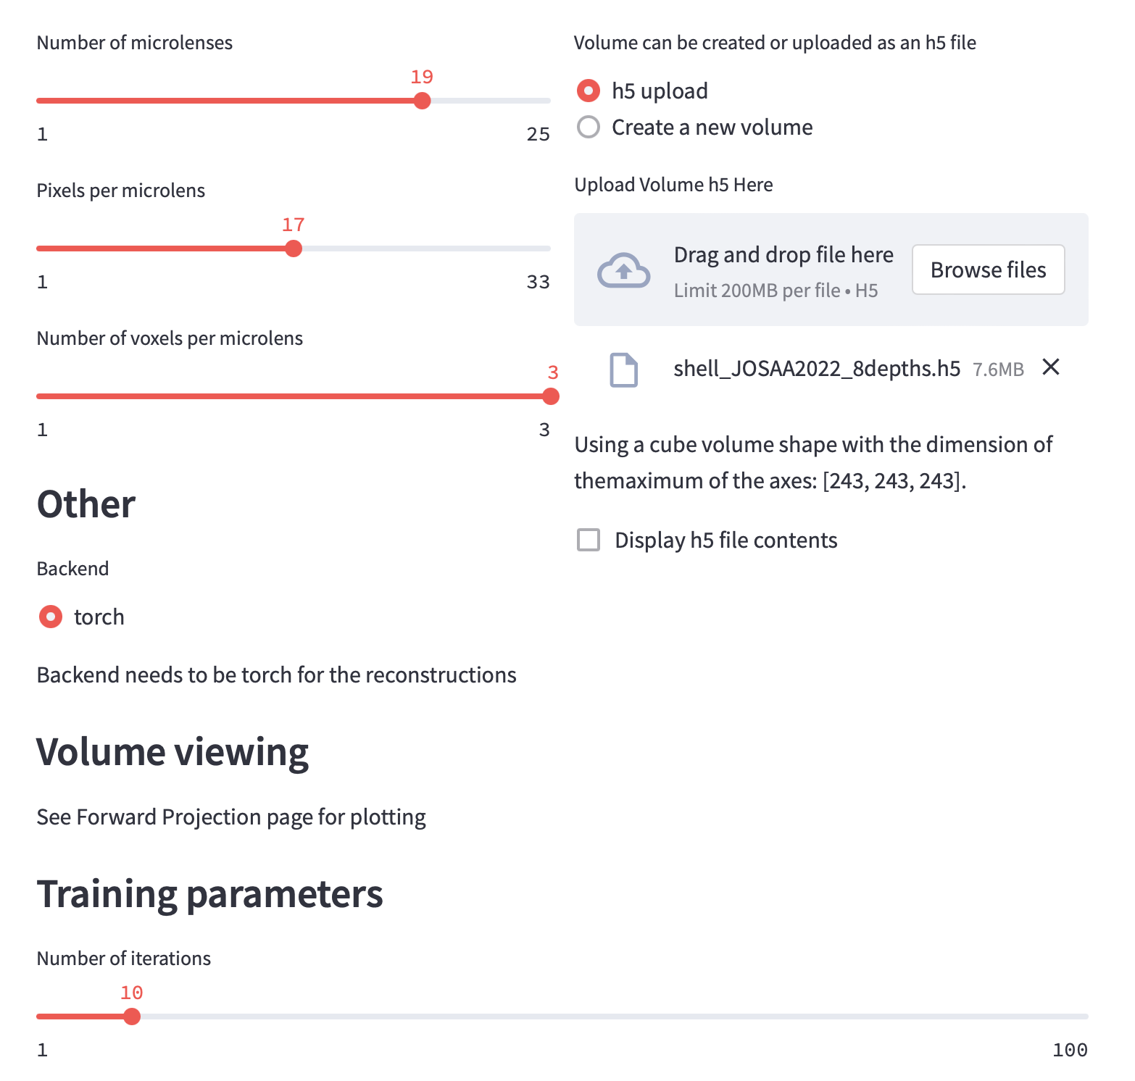

Note the cubic volume [243, 243, 243]

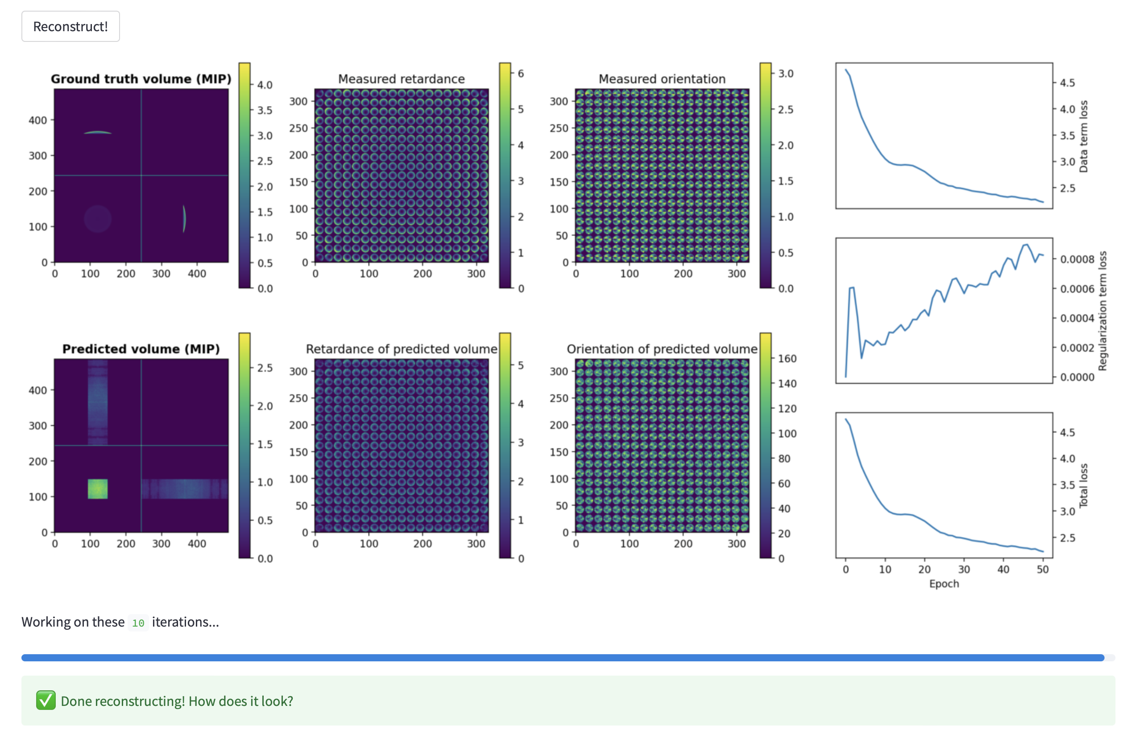

In the predicted volume, it seems that the X-position (axial position) of the retardance is ill defined, as it is expected for a thin, extended layer in Y and Z.

When I changed the number of voxels per microlens from 3 to 1, the ground truth volume and “measured” retardance and orientation maps did not change, but the predicted maps changed:

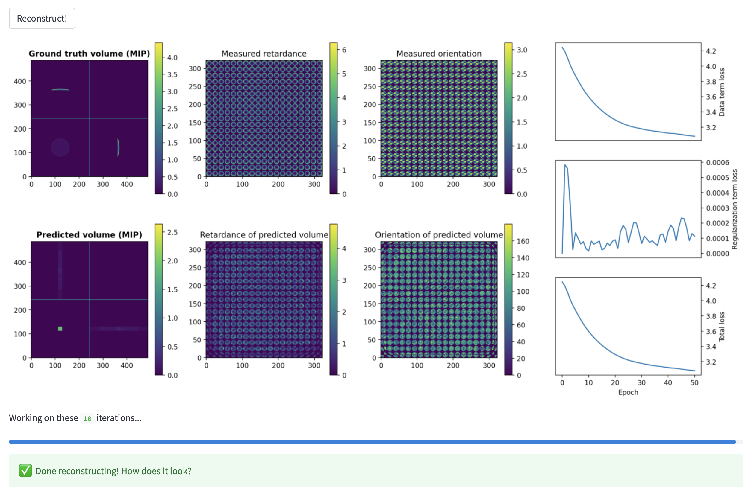

I don’t understand this behavior.